Functional electronic circuits Lab2

Student Name: CAO Xinyang

Student ID: 20321308

Variant: 2

**One-cycle device**

The picture with microarchitecture:

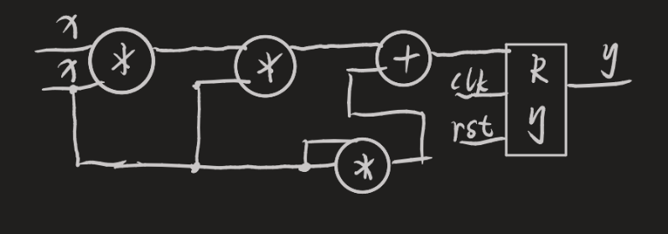

The timing diagram with simulation results:

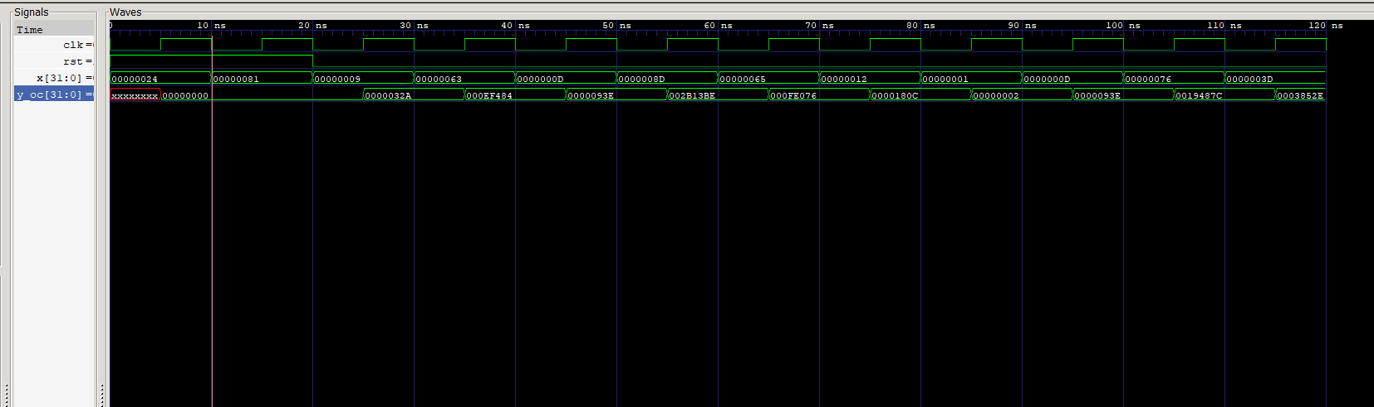

One-cycle calculation time: 10 ns

Code of the testbench and the device:

***device:***

module lab2_oc(

    input [31:0] x,

    input rst,

    input clk,

    output reg [31:0] y

);

always @(posedge clk) begin

    if (rst)

        y <= 0;

    else

        y <= x*x*x + x*x;

end

endmodule

***testbench:***

`timescale 1ns/1ps

module lab2_tb;

reg [31:0] x;

reg rst, clk;

wire [31:0] y_oc;

lab2_oc uut_oc(

    .clk(clk),

    .rst(rst),

    .x(x),

    .y(y_oc)

);

always #5 clk = ~clk;

always@(negedge clk) begin

    x = ($random % 256) & 8'hFF;

end

initial begin

    $dumpfile("time.vcd");

    $dumpvars(1, lab2_tb);

    clk = 0;

    rst = 1;

    x = 0;

    #20

    rst = 0;

    #100

    $finish;

end

endmodule

**Multi-cycle device**

The picture with microarchitecture:

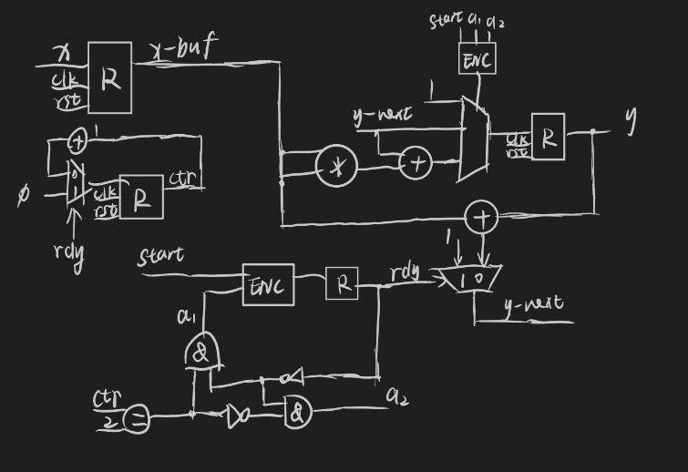

The timing diagram with simulation results:

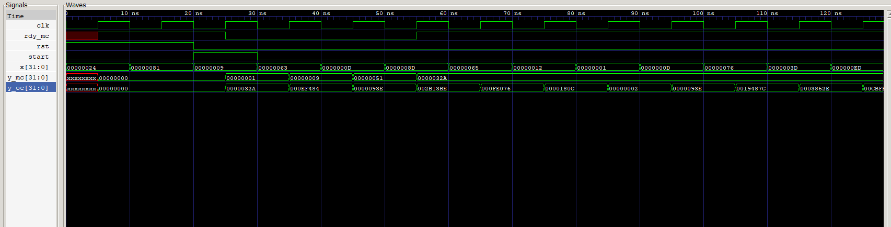

Multi-cycle calculation time: 50 ns

Code of the testbench and the device:

***device:***

module lab2_mc(

    input [31:0] x,

    input rst,

    input clk,

    input start,

    output reg [31:0] y,

    output reg rdy

);

reg [31:0] x_buf;

reg [2:0] ctr;

wire [2:0] ctr_next = (rdy)? 0: ctr + 1;

wire [31:0] y_next = (rdy)? 1: y*x_buf;

always @(posedge clk) begin

    if (rst) begin

        y <= 0;

        rdy <= 1;

        x_buf <= 0;

        ctr <= 0;

    end

    else begin

        ctr <= ctr_next;

        if (start) begin

            y <= 1;

            rdy <= 0;

            x_buf <= x;

        end

        if (!rdy)

            if (ctr == 2) begin

                y <= y_next + x_buf * x_buf;

                rdy <= 1;

            end else

                y <= y_next;

    end

end

endmodule

***testbench:***

`timescale 1ns/1ps

module lab2_tb;

reg [31:0] x;

reg rst, clk, start;

wire [31:0] y_oc, y_mc;

wire rdy_mc;

lab2_oc uut_oc(

    .clk(clk),

    .rst(rst),

    .x(x),

    .y(y_oc)

);

lab2_mc uut_mc(

    .clk(clk),

    .rst(rst),

    .start(start),

    .x(x),

    .rdy(rdy_mc),

    .y(y_mc)

);

always #5 clk = ~clk;

always@(negedge clk) begin

    x = ($random % 256) & 8'hFF;

end

initial begin

    $dumpfile("time.vcd");

    $dumpvars(1, lab2_tb);

    clk = 0;

    rst = 1;

    x = 0;

    start = 0;

    #20

    rst = 0;

    start = 1;

    #10

    start = 0;

    #100

    start = 1;

    #10

    start = 0;

    #100

    $finish;

end

endmodule

**Pipelined device**

The picture with microarchitecture:

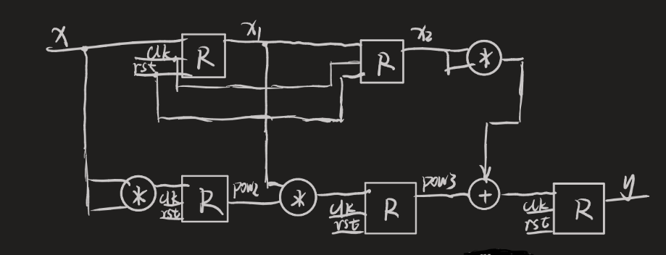

The timing diagram with simulation results:

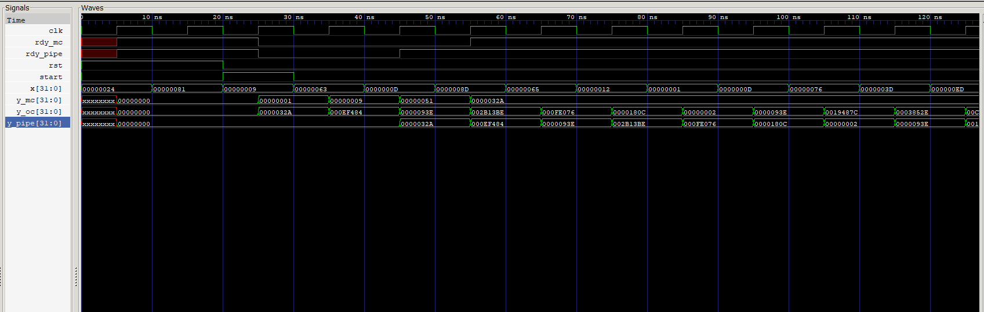

Pipeline calculation time for first result is 20 ns

for second is 10 ns

Code of the testbench and the device:

***device:***

module lab2_pipe(

    input [31:0] x,

    input rst,

    input clk,

    input start,

    output reg [31:0] y,

    output reg rdy

);

reg [31:0] pow2, pow3;

reg [31:0] x1, x2;

reg rdy1, rdy2;

always @(posedge clk) begin

    if (rst) begin

        y <= 0;

        rdy <= 1;

        rdy1 <= 0;

        rdy2 <= 0;

        pow2 <= 0;

        pow3 <= 0;

        x1 <= 0;

        x2 <= 0;

    end else begin

        if (start) begin

            rdy <= 0;

            rdy1 <= 1;

        end

        rdy2 <= rdy1;

        rdy <= rdy2;

        x1 <= x;

        x2 <= x1;

        pow2 <= x*x;

        pow3 <= pow2 * x1; //x*x*x

        y <= pow3 + x2 * x2; // x*x*x + x*x

    end

end

endmodule

***testbench:***

`timescale 1ns/1ps

module lab2_tb;

reg [31:0] x;

reg rst, clk, start;

wire [31:0] y_oc, y_mc, y_pipe;

wire rdy_mc, rdy_pipe;

lab2_oc uut_oc(

    .clk(clk),

    .rst(rst),

    .x(x),

    .y(y_oc)

);

lab2_mc uut_mc(

    .clk(clk),

    .rst(rst),

    .start(start),

    .x(x),

    .rdy(rdy_mc),

    .y(y_mc)

);

lab2_pipe uut_pipe(

    .clk(clk),

    .rst(rst),

    .start(start),

    .x(x),

    .rdy(rdy_pipe),

    .y(y_pipe)

);

always #5 clk = ~clk;

always@(negedge clk) begin

    x = ($random % 256) & 8'hFF;

end

initial begin

    $dumpfile("time.vcd");

    $dumpvars(1, lab2_tb);

    clk = 0;

    rst = 1;

    x = 0;

    start = 0;

    #20

    rst = 0;

    start = 1;

    #10

    start = 0;

    #100

    start = 1;

    #10

    start = 0;

    #100

    $finish;

end

endmodule